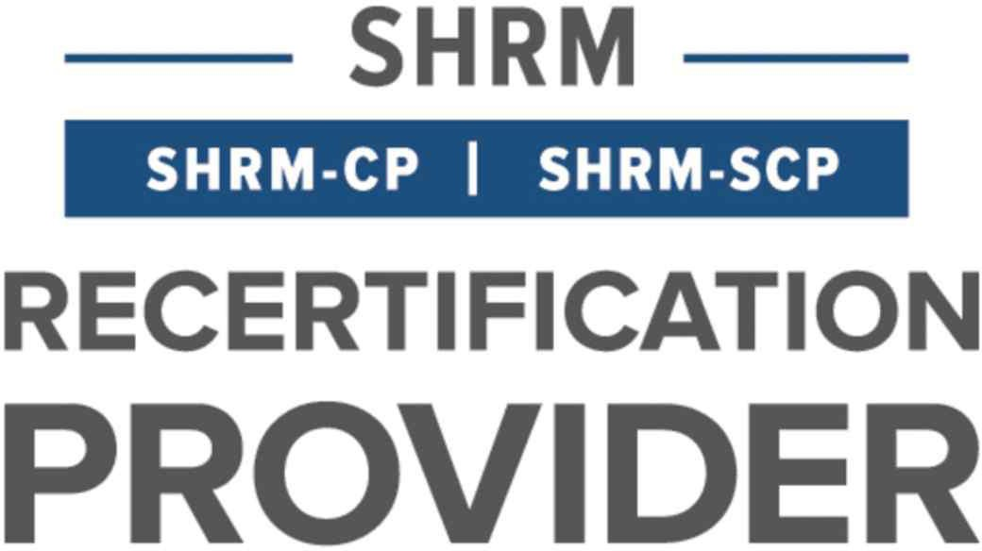
Marshall County

Human Resource Management Association
www.marshallcounty.shrm.org

Membership Application - 2023

Our members enjoy a wide range of exclusive beneﬁts, including our professional resources and networking with professionals just like you throughout the area.
Join today and you’ll get access to all our member beneﬁts:

- Regular meetings on the most relevant topics in HR, are designed to enhance your HR competencies and ensure you excel professionally
- Professional networking events to connect with dedicated professionals in the area
- Ongoing state and local information to keep you up to date on issues that could impact your workplace
MCHRMA is recognized by SHRM to offer Professional Development Credits (PDCs) for the SHRM-CP & SHRM-SCP
Chapter meetings are held on the third Wednesday of each month (excluding July & December) at 12:00 noon, location TBD.

(Use the “tab” key to type directly into the form)

Name: Job Title: Employer Name: Mailing Address: City, State, Zip Work Phone #:
Work Email: ____
Personal Email: _________
- SPHR ☐ GPHR
- PHR
- SHRM-CP ☐ SHRM-SCP
Professional Certifications

National SHRM Members
SHRM Membership No:
SHRM Expiration Date:
ANNUAL MEMBERSHIP DUES TO MCHRMA: ☐ $100.00 Executive membership ☐ $130.00 General membership

Executive Members: Executive membership shall be limited to: Those individuals who maintain a National SHRM Membership. Each person shall provide their SHRM membership number and the expiration date within fifteen (15) days of MCHRMA membership payment. National SHRM membership must be maintained throughout all of 2023. If National SHRM Membership is not renewed at expiration during 2023, Executive Membership will revert to General Membership and the difference in membership dues will be due at that time.
General Members: General membership shall be limited to: Those individuals who do not maintain a National SHRM Membership.

MCHRMA memberships are individually owned and are non-transferable. Membership will include all areas of professionals. We welcome those individuals working in Human Resource positions who devote more than 50% of their time to personnel, human resources, or industrial relations functions and those individuals who demonstrate a bona fide interest in human resource management (i.e., students, vendors, retired members, non-exempt levels). Meals will be included with all memberships.
Renewals of membership are due in January when the application is received. Only dues for new members are prorated, based on the month you join.
In applying for membership in the Marshall County Human Resource Management Association (MCHRMA), I acknowledge that I meet the membership requirements for this organization as set forth in this application. I agree to review MCHRMA’s Constitution and By-Laws, rules, and regulations when received and to follow them to assist MCHRMA in carrying out its objectives. I understand that concurrent membership in MCHRMA must be maintained. I also understand that my application fee (make check payable to MCHRMA) must be submitted with this application to be considered for membership. I further understand that my membership is individual and non-transferable.

Signed:
Date:

REFERRED BY:

Mail this completed form with payment to:
MCHRMA , (c/o Julie Schwieterman) 1301 Gunter Avenue, Guntersville, AL 35976

